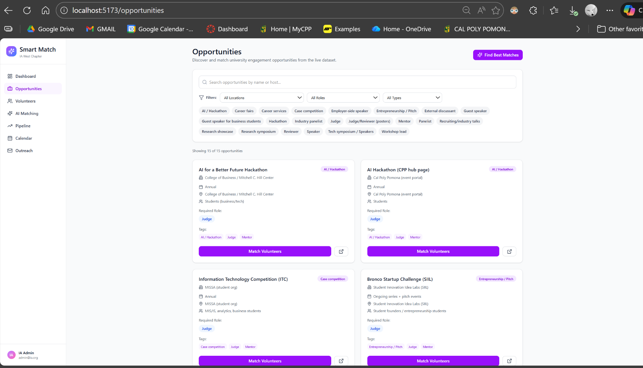
Image #1
* Really like this UI here, we need to change the coloring schemes to matches that of the landing page (professional white & shades of blue instead of generic AI boiler plate gradient purple)

- “Match Volunteers” button do not work

Keep this page (from V1.1)
Volunteer Profile:
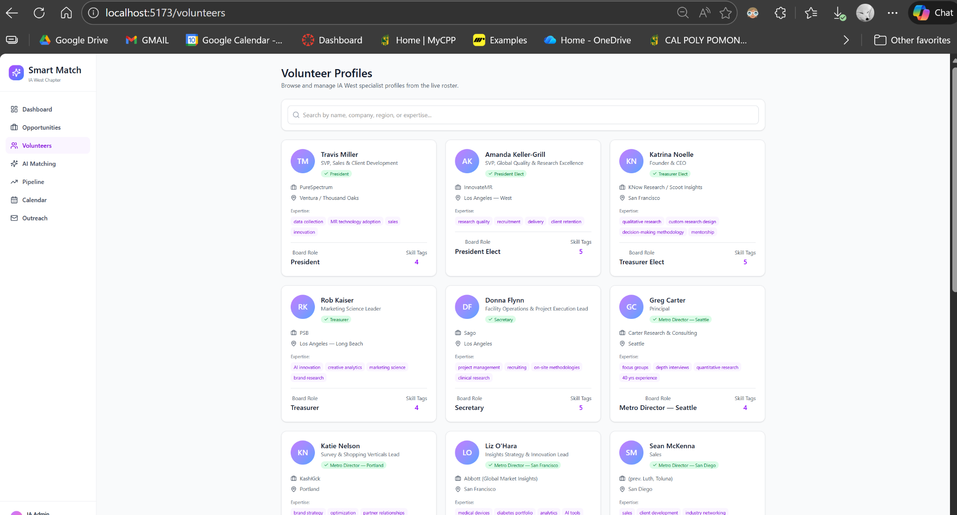
Image#2
* Keep this page as a way for the coordinator to view & manage all available IA West volunteers personnel.
* We want to add fatigue measurements to them too as a calculation algorithm based on how many events they had been matched with in the past month (this can be a meter, we want to prioritize work/life balance between our volunteers as matching & having our volunteers working too much will results in burnt-out)
Once we click on each volunteers:
It should return a dashboard of this, as coordinator, we should be able to view all their history, recent events, metrics, ROI (of student engagements from previous events they went to and got students to sign up membership from the QR code)
Image#3
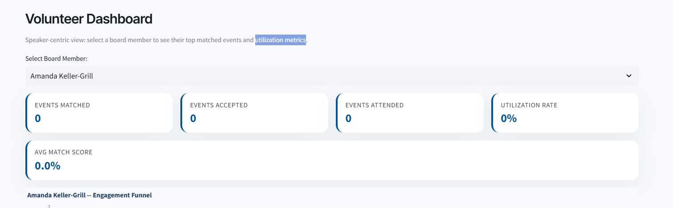
^ we should have the purple gradients changed into this coloring scheme, which is more professional based especially for IA West organization
For analytic page, add this as a feature - a geographic map to cover the West-coast that can be zoomed out, showcasing heatmap of event densities (active events & future events), have coloring schemes (have contrasting colors to indicate an event that IA West has a representative go and one that is without (needing match)) - Follow general website coloring scheme
Image#4
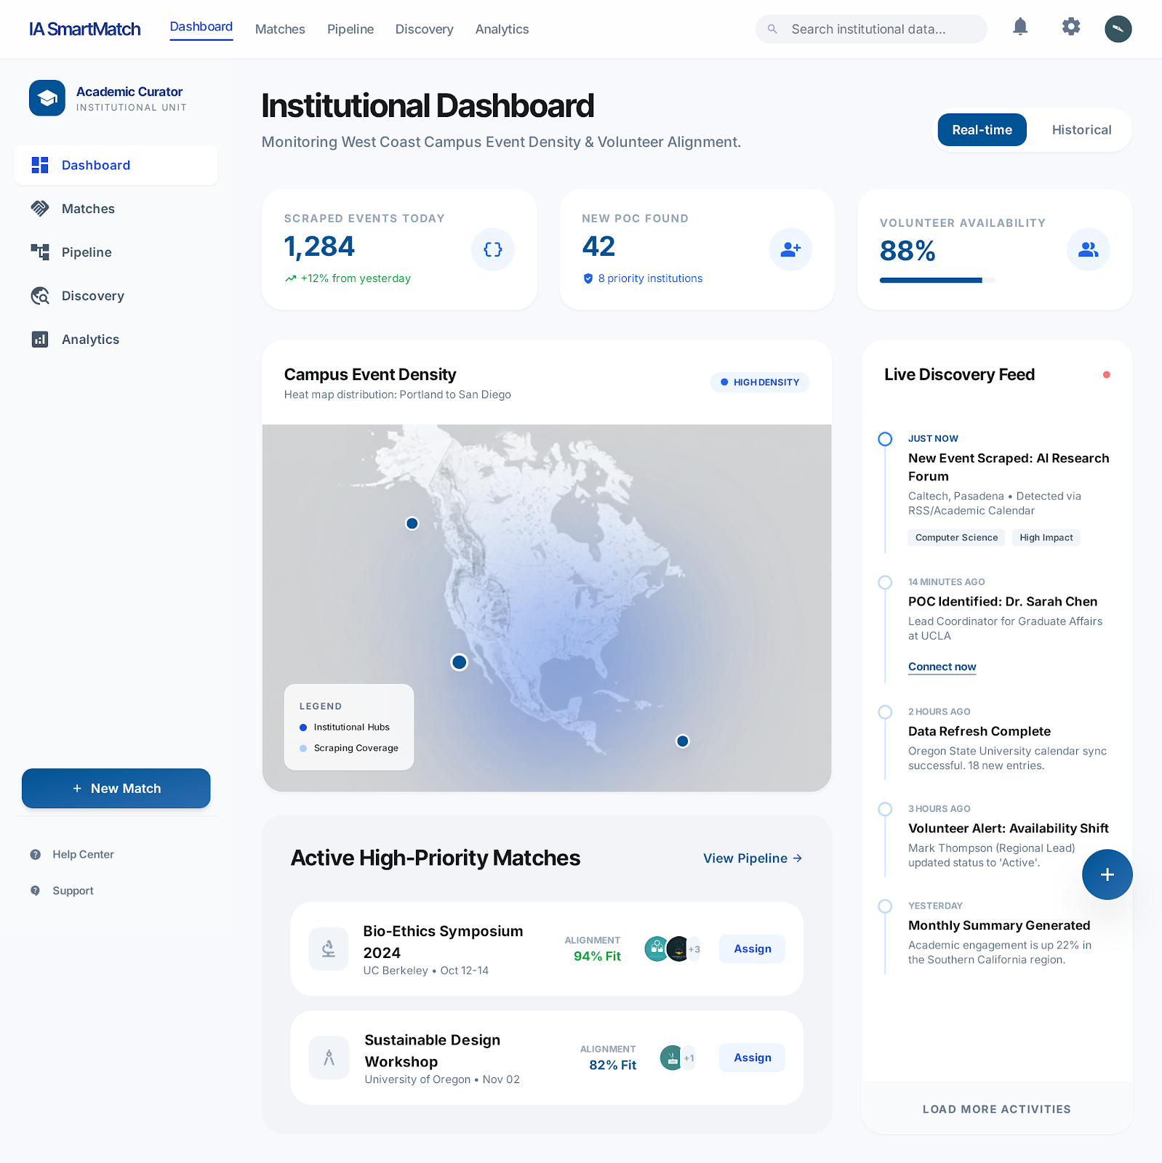
- The discovery feed is important - it acts as a notice to inform the coordinator of everything that is going on. In essential the coordinator is the orchestrator to control our NemoClaw (agent that does automatic outreach once coordinator approve & the volunteer accepts the matching from coordinator)
-

Landing Page (Image #4) code’s:
Remove the top part of IA Smart Match top menu navigation - those will be available when you sign in as coordinator
This is a landing page, the only interactive button should be Sign in - lead to sign in portal (use the portal from V1.0) and the landing page from (v1.0, however, this should be recreated in our new frontend frameworks, not a pre-rendered HTML part that cannot be interactive)
- Opportunity density map should be from hard-coded data for now.
<!DOCTYPE html>

<html class="light" lang="en"><head>
<meta charset="utf-8"/>
<meta content="width=device-width, initial-scale=1.0" name="viewport"/>
<title>IA SmartMatch | Specialist-to-Opportunity AI Matching</title>
<script src="https://cdn.tailwindcss.com?plugins=forms,container-queries"></script>
<link href="https://fonts.googleapis.com/css2?family=Inter:wght@400;500;600&amp;family=Inter+Tight:wght@600;700;800&amp;display=swap" rel="stylesheet"/>
<link href="https://fonts.googleapis.com/css2?family=Material+Symbols+Outlined:wght,FILL@100..700,0..1&amp;display=swap" rel="stylesheet"/>
<script id="tailwind-config">
tailwind.config = {
darkMode: "class",
theme: {
extend: {
colors: {
"secondary-container": "#d5e0f7",
"on-tertiary-fixed-variant": "#693c00",
"on-primary": "#ffffff",
"on-secondary": "#ffffff",
"on-error-container": "#93000a",
"secondary-fixed": "#d8e3fa",
"error": "#ba1a1a",
"outline-variant": "#c1c7d2",
"on-secondary-fixed": "#111c2c",
"on-surface": "#191c1e",
"inverse-primary": "#a2c9ff",
"surface-dim": "#d8dadd",
"surface-container-low": "#f2f4f7",
"on-background": "#191c1e",
"primary-container": "#2b6cb0",
"on-secondary-container": "#586377",
"inverse-on-surface": "#eff1f4",
"on-secondary-fixed-variant": "#3c475a",
"background": "#f7f9fc",
"on-primary-container": "#e1ecff",
"primary-fixed": "#d3e4ff",
"tertiary-container": "#9a5b00",
"tertiary-fixed-dim": "#ffb86e",
"on-error": "#ffffff",
"secondary-fixed-dim": "#bcc7dd",
"tertiary-fixed": "#ffdcbd",
"secondary": "#545f72",
"on-primary-fixed-variant": "#004881",
"surface-container-highest": "#e0e3e6",
"surface-bright": "#f7f9fc",
"surface-tint": "#1960a3",
"on-primary-fixed": "#001c38",
"on-tertiary": "#ffffff",
"inverse-surface": "#2d3133",
"surface-container-lowest": "#ffffff",
"on-tertiary-container": "#ffe7d2",
"error-container": "#ffdad6",
"on-tertiary-fixed": "#2c1600",
"primary": "#005394",
"surface-container-high": "#e6e8eb",
"surface-container": "#eceef1",
"on-surface-variant": "#414750",
"tertiary": "#784600",
"outline": "#727782",
"surface": "#f7f9fc",
"primary-fixed-dim": "#a2c9ff",
"surface-variant": "#e0e3e6"
},
fontFamily: {
"headline": ["Inter Tight"],
"body": ["Inter"],
"label": ["Inter"]
},
borderRadius: {"DEFAULT": "0.25rem", "lg": "0.5rem", "xl": "0.75rem", "2xl": "1.5rem", "full": "9999px"},
},
},
}
</script>
<style>
.material-symbols-outlined {
font-variation-settings: 'FILL' 0, 'wght' 400, 'GRAD' 0, 'opsz' 24;
}
.hero-gradient {
background: linear-gradient(135deg, #005394 0%, #2b6cb0 100%);
}
.glass-panel {
background: rgba(255, 255, 255, 0.8);
backdrop-filter: blur(24px);
}
</style>
</head>
<body class="bg-surface font-body text-on-surface">
<!-- Top Navigation Shell -->
<nav class="bg-white/80 dark:bg-slate-900/80 backdrop-blur-xl shadow-sm dark:shadow-none docked full-width top-0 z-50 flex justify-between items-center w-full px-8 py-4 max-w-full mx-auto fixed">
<div class="flex items-center gap-8">
<span class="text-xl font-bold tracking-tight text-slate-900 dark:text-slate-50 font-headline">IA SmartMatch</span>
<div class="hidden md:flex gap-6">
<a class="text-blue-700 dark:text-blue-400 font-semibold border-b-2 border-blue-700 dark:border-blue-400 pb-1" href="#">Dashboard</a>
<a class="text-slate-600 dark:text-slate-400 hover:text-blue-600 dark:hover:text-blue-300 transition-colors" href="#">Matches</a>
<a class="text-slate-600 dark:text-slate-400 hover:text-blue-600 dark:hover:text-blue-300 transition-colors" href="#">Pipeline</a>
<a class="text-slate-600 dark:text-slate-400 hover:text-blue-600 dark:hover:text-blue-300 transition-colors" href="#">Discovery</a>
<a class="text-slate-600 dark:text-slate-400 hover:text-blue-600 dark:hover:text-blue-300 transition-colors" href="#">Analytics</a>
</div>
</div>
<div class="flex gap-4">
<button class="text-slate-600 font-medium px-4 py-2 hover:bg-slate-50 dark:hover:bg-slate-800 rounded-lg transition-all">Sign in</button>
<button class="hero-gradient text-white px-6 py-2 rounded-xl font-semibold shadow-sm hover:opacity-90 active:scale-[0.98] transition-all">Add Specialist</button>
</div>
</nav>
<main class="pt-24">
<!-- Hero Section -->
<section class="px-8 py-20 max-w-7xl mx-auto flex flex-col items-center text-center">
<span class="text-primary font-semibold tracking-wider uppercase text-sm mb-4">AI-Driven Opportunity Matching for IA West</span>
<h1 class="text-5xl md:text-7xl font-bold font-headline tracking-tight text-on-surface max-w-4xl leading-[1.1] mb-8">
Match your specialist database with every university opportunity
</h1>
<p class="text-xl text-on-surface-variant max-w-2xl mb-12">
Bridge the gap between your internal industry expertise and live academic needs through automated web-scraped signals and high-fidelity matching.
</p>
<div class="flex flex-wrap gap-4 justify-center">
<button class="hero-gradient text-on-primary px-8 py-4 rounded-xl text-lg font-bold shadow-lg">Start Matching</button>
<button class="bg-surface-container-high text-on-surface px-8 py-4 rounded-xl text-lg font-semibold">View Demo</button>
</div>
</section>
<!-- Product Preview Mockup (Bento Style) -->
<section class="px-8 pb-32 max-w-7xl mx-auto">
<div class="bg-surface-container-low rounded-[2.5rem] p-4 md:p-8 shadow-sm">
<div class="grid grid-cols-1 lg:grid-cols-12 gap-8">
<!-- Main Event Card -->
<div class="lg:col-span-8 bg-surface-container-lowest rounded-2xl p-8 shadow-sm">
<div class="flex justify-between items-start mb-12">
<div>
<span class="text-primary font-bold text-xs uppercase tracking-widest mb-2 block">Scraped Opportunity</span>
<h3 class="text-3xl font-headline font-bold">UCLA Career Fair 2026</h3>
<p class="text-on-surface-variant mt-1">Luskin Conference Center • May 14, 2026</p>
</div>
<div class="bg-secondary-fixed text-on-secondary-fixed px-4 py-2 rounded-full flex items-center gap-2">
<span class="material-symbols-outlined text-sm">school</span>
<span class="text-sm font-semibold">High Priority</span>
</div>
</div>
<div class="space-y-6">
<h4 class="text-sm font-bold text-on-surface-variant uppercase tracking-tighter">Database Specialist Recommendations</h4>
<!-- Recommendation 1 -->
<div class="flex items-center justify-between p-6 bg-surface-container rounded-2xl border border-primary/10">
<div class="flex items-center gap-4">
<div class="w-12 h-12 rounded-full bg-primary-container flex items-center justify-center text-on-primary-container font-bold">TM</div>
<div>
<p class="font-bold text-lg">Travis Miller</p>
<p class="text-sm text-on-surface-variant">SVP Sales, TechCorp • Specialist CRM</p>
</div>
</div>
<div class="flex gap-8 items-center">
<div class="text-center">
<p class="text-xs text-on-surface-variant uppercase">Match Score</p>
<p class="text-xl font-bold text-primary">94%</p>
</div>
<button class="bg-primary text-white px-4 py-2 rounded-lg text-sm font-bold">Sync CRM</button>
</div>
</div>
<!-- Detail View Integration -->
<div class="grid grid-cols-3 gap-4">
<div class="bg-surface p-4 rounded-xl text-center">
<p class="text-primary font-bold text-lg">35%</p>
<p class="text-xs text-on-surface-variant uppercase font-medium">Domain Relevance</p>
</div>
<div class="bg-surface p-4 rounded-xl text-center">
<p class="text-primary font-bold text-lg">25%</p>
<p class="text-xs text-on-surface-variant uppercase font-medium">Scraped Role Fit</p>
</div>
<div class="bg-surface p-4 rounded-xl text-center">
<p class="text-primary font-bold text-lg">20%</p>
<p class="text-xs text-on-surface-variant uppercase font-medium">Location</p>
</div>
</div>
</div>
</div>
<!-- AI Explanation Column -->
<div class="lg:col-span-4 space-y-8">
<div class="bg-primary-container text-on-primary-container p-8 rounded-2xl h-full flex flex-col">
<div class="flex items-center gap-2 mb-6">
<span class="material-symbols-outlined" data-weight="fill">auto_awesome</span>
<h4 class="font-headline font-bold text-xl">Bridge Logic</h4>
</div>
<p class="text-lg leading-relaxed mb-8 opacity-90">
Travis's profile in your Specialist CRM aligns with UCLA's web-scraped event data focused on "Sales Leadership in SaaS." His history suggests a high-fidelity match for this discovered opportunity.
</p>
<div class="mt-auto space-y-4">
<div class="flex justify-between text-sm">
<span>Signal Integrity</span>
<span class="font-bold">Excellent</span>
</div>
<div class="w-full bg-white/20 h-1 rounded-full overflow-hidden">
<div class="bg-white h-full w-[92%]"></div>
</div>
</div>
</div>
</div>
</div>
</div>
</section>
<!-- Features Grid -->
<section class="bg-surface-container-low py-32">
<div class="px-8 max-w-7xl mx-auto">
<div class="mb-20">
<h2 class="text-4xl font-headline font-bold mb-4">Complete Specialist Engagement Pipeline</h2>
<p class="text-on-surface-variant max-w-xl">A unified platform to bridge your internal specialist database with external university opportunities.</p>
</div>
<div class="grid grid-cols-1 md:grid-cols-3 gap-12">
<div class="flex flex-col gap-6">
<div class="w-14 h-14 rounded-2xl bg-white flex items-center justify-center shadow-sm text-primary">
<span class="material-symbols-outlined text-3xl">language</span>
</div>
<h3 class="text-2xl font-headline font-bold">Proprietary Web Scraping</h3>
<p class="text-on-surface-variant">Real-time automation monitors university portals to identify speaking slots, panels, and academic needs across the West Coast.</p>
</div>
<div class="flex flex-col gap-6">
<div class="w-14 h-14 rounded-2xl bg-white flex items-center justify-center shadow-sm text-primary">
<span class="material-symbols-outlined text-3xl">groups</span>
</div>
<h3 class="text-2xl font-headline font-bold">Industry Specialist CRM</h3>
<p class="text-on-surface-variant">Centralize your internal database of volunteers with enriched profiles, expertise tracking, and availability management.</p>
</div>
<div class="flex flex-col gap-6">
<div class="w-14 h-14 rounded-2xl bg-white flex items-center justify-center shadow-sm text-primary">
<span class="material-symbols-outlined text-3xl">hub</span>
</div>
<h3 class="text-2xl font-headline font-bold">Bridge Matching</h3>
<p class="text-on-surface-variant">Proprietary algorithms bridge the gap between internal CRM expertise and scraped event requirements for optimal placement.</p>
</div>
</div>
</div>
</section>
<!-- Technical Visualization -->
<section class="py-32 px-8 max-w-7xl mx-auto overflow-hidden">
<div class="grid grid-cols-1 lg:grid-cols-2 gap-20 items-center">
<div>
<h2 class="text-4xl font-headline font-bold mb-6 leading-tight">The Bridge: 6-factor MATCH_SCORE</h2>
<p class="text-lg text-on-surface-variant mb-10">Our engine cross-references internal specialist data with scraped event parameters to maximize the impact of every engagement.</p>
<div class="bg-white dark:bg-slate-800 p-8 rounded-3xl shadow-sm border border-outline-variant/10">
<div class="flex items-center gap-3 mb-6">
<span class="material-symbols-outlined text-primary">analytics</span>
<h3 class="text-xl font-headline font-bold">Match Verification</h3>
</div>
<div class="space-y-6">
<div class="flex gap-4">
<div class="w-10 h-10 rounded-full bg-primary/10 flex items-center justify-center shrink-0">
<span class="material-symbols-outlined text-primary text-xl">database</span>
</div>
<div>
<p class="font-bold text-sm uppercase tracking-wider text-on-surface-variant mb-1">CRM Profile Sync</p>
<p class="text-on-surface">Specialist expertise in SaaS sales leadership matches 100% of the course curriculum scraped from UCLA.</p>
</div>
</div>
<div class="flex gap-4">
<div class="w-10 h-10 rounded-full bg-primary/10 flex items-center justify-center shrink-0">
<span class="material-symbols-outlined text-primary text-xl">travel_explore</span>
</div>
<div>
<p class="font-bold text-sm uppercase tracking-wider text-on-surface-variant mb-1">Scraped Calendar Match</p>
<p class="text-on-surface">CRM availability shows 3 overlapping slots with the university's priority window discovered via scraping.</p>
</div>
</div>
<div class="flex gap-4">
<div class="w-10 h-10 rounded-full bg-primary/10 flex items-center justify-center shrink-0">
<span class="material-symbols-outlined text-primary text-xl">location_on</span>
</div>
<div>
<p class="font-bold text-sm uppercase tracking-wider text-on-surface-variant mb-1">Geospatial Synergies</p>
<p class="text-on-surface">Internal location data aligns with the scraped event venue, ensuring low-friction logistical coordination.</p>
</div>
</div>
</div>
</div>
</div>
<div class="relative">
<div class="bg-surface-container rounded-3xl p-8 aspect-square flex flex-col items-center justify-center relative"><div class="absolute inset-0 bg-primary/5 rounded-3xl transform rotate-2 -z-10"></div>
<div class="w-full max-w-md aspect-square relative flex items-center justify-center">
<!-- Outer Ring (Segmented) -->
<svg class="w-full h-full transform -rotate-90" viewbox="0 0 100 100">
<!-- CRM Expertise (35%) -->
<circle class="text-primary" cx="50" cy="50" fill="transparent" r="42" stroke="currentColor" stroke-dasharray="35 65" stroke-dashoffset="0" stroke-linecap="round" stroke-width="8"></circle>
<!-- Scraped Event Fit (25%) -->
<circle class="text-primary/70" cx="50" cy="50" fill="transparent" r="42" stroke="currentColor" stroke-dasharray="25 75" stroke-dashoffset="-36" stroke-linecap="round" stroke-width="8"></circle>
<!-- Proximity (20%) -->
<circle class="text-primary/50" cx="50" cy="50" fill="transparent" r="42" stroke="currentColor" stroke-dasharray="20 80" stroke-dashoffset="-62" stroke-linecap="round" stroke-width="8"></circle>
<!-- Calendar Sync (15%) -->
<circle class="text-primary/30" cx="50" cy="50" fill="transparent" r="42" stroke="currentColor" stroke-dasharray="15 85" stroke-dashoffset="-83" stroke-linecap="round" stroke-width="8"></circle>
<!-- Engagement History (5%) -->
<circle class="text-primary/10" cx="50" cy="50" fill="transparent" r="42" stroke="currentColor" stroke-dasharray="5 95" stroke-dashoffset="-99" stroke-linecap="round" stroke-width="8"></circle>
</svg>
<div class="absolute inset-0 flex flex-col items-center justify-center">
<div class="w-32 h-32 bg-white dark:bg-slate-900 rounded-full shadow-2xl flex flex-col items-center justify-center border-4 border-surface">
<span class="text-xs uppercase font-bold text-on-surface-variant opacity-60">Match Score</span>
<span class="text-5xl font-headline font-bold text-primary">94</span>
</div>
</div>
<!-- Labels -->
<div class="absolute -top-4 -right-4 bg-white px-4 py-2 rounded-xl shadow-lg border border-outline-variant/10 text-xs font-bold">
<div class="flex items-center gap-2">
<div class="w-2 h-2 rounded-full bg-primary"></div>
CRM Expertise: 35%
</div>
</div>
<div class="absolute top-1/2 -right-12 bg-white px-4 py-2 rounded-xl shadow-lg border border-outline-variant/10 text-xs font-bold">
<div class="flex items-center gap-2">
<div class="w-2 h-2 rounded-full bg-primary/70"></div>
Scraped Event Fit: 25%
</div>
</div>
<div class="absolute -bottom-4 right-4 bg-white px-4 py-2 rounded-xl shadow-lg border border-outline-variant/10 text-xs font-bold">
<div class="flex items-center gap-2">
<div class="w-2 h-2 rounded-full bg-primary/50"></div>
Proximity: 20%
</div>
</div>
<div class="absolute -bottom-8 left-0 bg-white px-4 py-2 rounded-xl shadow-lg border border-outline-variant/10 text-xs font-bold">
<div class="flex items-center gap-2">
<div class="w-2 h-2 rounded-full bg-primary/30"></div>
Calendar Sync: 15%
</div>
</div>
<div class="absolute top-1/4 -left-12 bg-white px-4 py-2 rounded-xl shadow-lg border border-outline-variant/10 text-xs font-bold">
<div class="flex items-center gap-2">
<div class="w-2 h-2 rounded-full bg-primary/10"></div>
History: 5%
</div>
</div>
</div>
<div class="mt-12 text-center">
<p class="font-headline font-bold text-xl">CRM Specialist Profile: Travis Miller</p>
<p class="text-on-surface-variant">Bridged with Scraped UCLA Opportunity Data</p>
</div></div>
</div>
</div>
</section>
<!-- Automation Pipeline -->
<section class="bg-surface-container py-32 px-8 overflow-hidden">
<div class="max-w-7xl mx-auto">
<div class="grid lg:grid-cols-2 gap-24 items-center">
<div class="order-2 lg:order-1 relative">
<div class="space-y-4">
<div class="bg-white p-6 rounded-2xl shadow-sm border-l-4 border-primary">
<p class="font-mono text-sm text-on-surface-variant flex gap-2">
<span class="text-primary">SCRAPE</span> https://career.ucla.edu/api/events
</p>
</div>
<div class="bg-white p-6 rounded-2xl shadow-sm ml-8 opacity-80">
<div class="flex items-center gap-4 mb-2">
<div class="w-3 h-3 rounded-full bg-green-500"></div>
<span class="text-sm font-bold uppercase tracking-wider">Parsing Discovered Data...</span>
</div>
<div class="space-y-2">
<div class="h-2 bg-surface-container rounded w-full"></div>
<div class="h-2 bg-surface-container rounded w-[80%]"></div>
</div>
</div>
<div class="bg-primary p-6 rounded-2xl shadow-lg ml-16 text-white flex items-center justify-between">
<div class="flex items-center gap-4">
<span class="material-symbols-outlined">sync</span>
<span class="font-bold">Syncing with Specialist CRM...</span>
</div>
<span class="material-symbols-outlined">chevron_right</span>
</div>
</div>
</div>
<div class="order-1 lg:order-2">
<h2 class="text-4xl font-headline font-bold mb-8">Proprietary Web Scraping</h2>
<p class="text-lg text-on-surface-variant leading-relaxed mb-8">
Our scraping pipeline monitors UCLA, USC, and dozens of other university sites in real-time. No more manual searching; discovered opportunities are instantly cross-referenced against your internal database of specialists.
</p>
<div class="flex items-center gap-6">
<div class="flex -space-x-4">
<div class="w-12 h-12 rounded-full border-4 border-white bg-slate-200 flex items-center justify-center text-xs font-bold">UCLA</div>
<div class="w-12 h-12 rounded-full border-4 border-white bg-slate-200 flex items-center justify-center text-xs font-bold">USC</div>
<div class="w-12 h-12 rounded-full border-4 border-white bg-slate-200 flex items-center justify-center text-xs font-bold">SDSU</div>
</div>
<p class="text-sm font-bold text-on-surface-variant">+42 Sources Monitored</p>
</div>
</div>
</div>
</div>
</section>
<!-- Analytics Dashboard Section -->
<section class="py-32 px-8 max-w-7xl mx-auto">
<h2 class="text-4xl font-headline font-bold mb-16 text-center">Engagement &amp; Scraping Analytics</h2>
<div class="grid grid-cols-1 lg:grid-cols-3 gap-8">
<div class="lg:col-span-2 bg-surface-container-lowest rounded-3xl p-8 shadow-sm">
<div class="flex justify-between items-center mb-12">
<h3 class="text-xl font-bold font-headline">Opportunity Density Heat Map</h3>
<div class="flex gap-2">
<span class="px-3 py-1 bg-surface-container rounded-lg text-xs font-bold">Scraped Leads</span>
<span class="px-3 py-1 bg-surface-container rounded-lg text-xs font-bold">CRM Matches</span>
</div>
</div>
<div class="h-80 bg-surface-container rounded-2xl relative overflow-hidden flex items-center justify-center">
<img class="absolute inset-0 w-full h-full object-cover opacity-20 grayscale" data-alt="Stylized map showing engagement density in West Coast US" src="https://lh3.googleusercontent.com/aida-public/AB6AXuDVVGflkW-LVtYOSqe7GCr0lhFgbt-Z_lxHtAd9kaPiizCcZ1rDpmA0PtB2ZKGB1R5NTCp9d-dPYmhoCgGJzuodk0rBC7deLrNaP_6bvqE_8XLlyULJlp20XLEAV21a5vLRpor_pP-dOA4tkVggzIMdIgm_fG7aJTC1nyCjd4mZlrmiUIt8xl-2Evic37HP4ul8YgUGjz1TDyR5WT2QuHxkjGj0wl6i_s80kil_nktIU4-JiY0z3c4NbgYkbkt5GS0xs9XoCshP_6s"/>
<div class="relative flex flex-col items-center gap-2">
<div class="w-12 h-12 bg-primary rounded-full animate-pulse opacity-50 absolute -top-8 -left-20"></div>
<div class="w-16 h-16 bg-primary rounded-full animate-pulse opacity-70"></div>
<p class="font-bold text-primary">High Opportunity: Los Angeles Hub</p>
</div>
</div>
</div>
<div class="bg-surface-container-lowest rounded-3xl p-8 shadow-sm">
<h3 class="text-xl font-bold font-headline mb-12">Matching Funnel</h3>
<div class="space-y-8">
<div>
<div class="flex justify-between mb-2">
<span class="text-sm font-bold">Discovered (Scraped)</span>
<span class="text-sm">2,481</span>
</div>
<div class="h-3 bg-surface-container rounded-full overflow-hidden">
<div class="h-full bg-primary w-full"></div>
</div>
</div>
<div>
<div class="flex justify-between mb-2">
<span class="text-sm font-bold">CRM Potential Matches</span>
<span class="text-sm">842</span>
</div>
<div class="h-3 bg-surface-container rounded-full overflow-hidden">
<div class="h-full bg-primary w-[34%]"></div>
</div>
</div>
<div>
<div class="flex justify-between mb-2">
<span class="text-sm font-bold">Specialist Confirmed</span>
<span class="text-sm">114</span>
</div>
<div class="h-3 bg-surface-container rounded-full overflow-hidden">
<div class="h-full bg-primary w-[5%]"></div>
</div>
</div>
</div>
</div>
</div>
</section>
<!-- Partner Showcase -->
<section class="py-24 border-y border-surface-container">
<div class="px-8 max-w-7xl mx-auto">
<p class="text-center text-on-surface-variant font-bold uppercase tracking-widest text-xs mb-12">Bridging CRM Data to</p>
<div class="flex flex-wrap justify-center gap-12 md:gap-24 grayscale opacity-60">
<span class="text-2xl font-headline font-extrabold">CPP</span>
<span class="text-2xl font-headline font-extrabold">UCLA</span>
<span class="text-2xl font-headline font-extrabold">SDSU</span>
<span class="text-2xl font-headline font-extrabold">UC DAVIS</span>
<span class="text-2xl font-headline font-extrabold">USC</span>
<span class="text-2xl font-headline font-extrabold">PORTLAND STATE</span>
</div>
</div>
</section>
<!-- Final CTA -->
<section class="px-8 py-32 max-w-5xl mx-auto text-center">
<h2 class="text-5xl font-headline font-bold mb-8">Ready to sync your database with the web?</h2>
<p class="text-xl text-on-surface-variant mb-12 max-w-2xl mx-auto">Join the IA West network and transform how your internal specialist database interacts with real-world university opportunities.</p>
<div class="flex flex-wrap gap-4 justify-center">
<button class="hero-gradient text-on-primary px-10 py-5 rounded-2xl text-xl font-bold shadow-xl active:scale-95 transition-all">Connect Database</button>
<button class="bg-surface-container-lowest text-on-surface px-10 py-5 rounded-2xl text-xl font-bold shadow-sm border border-outline-variant/20 hover:bg-surface-container transition-all">Schedule Demo</button>
</div>
</section>
</main>
<!-- Footer -->
<footer class="w-full border-t border-slate-100 dark:border-slate-800 bg-white dark:bg-slate-900">
<div class="grid grid-cols-2 md:grid-cols-4 lg:grid-cols-6 gap-8 px-12 py-16 w-full max-w-7xl mx-auto">
<div class="col-span-2">
<span class="text-md font-bold text-slate-900 dark:text-slate-100 font-headline mb-4 block">IA SmartMatch</span>
<p class="text-slate-500 dark:text-slate-400 max-w-xs">Connecting internal specialist CRM data with real-time scraped academic opportunities.</p>
</div>
<div class="space-y-4">
<p class="font-headline font-semibold text-slate-900 dark:text-white">Product</p>
<ul class="space-y-2">
<li><a class="text-slate-500 dark:text-slate-400 hover:text-blue-700 transition-colors" href="#">Specialist CRM</a></li>
<li><a class="text-slate-500 dark:text-slate-400 hover:text-blue-700 transition-colors" href="#">Scraping Engine</a></li>
</ul>
</div>
<div class="space-y-4">
<p class="font-headline font-semibold text-slate-900 dark:text-white">About</p>
<ul class="space-y-2">
<li><a class="text-slate-500 dark:text-slate-400 hover:text-blue-700 transition-colors" href="#">About IA West</a></li>
<li><a class="text-slate-500 dark:text-slate-400 hover:text-blue-700 transition-colors" href="#">Contact</a></li>
</ul>
</div>
<div class="space-y-4">
<p class="font-headline font-semibold text-slate-900 dark:text-white">Legal</p>
<ul class="space-y-2">
<li><a class="text-slate-500 dark:text-slate-400 hover:text-blue-700 transition-colors" href="#">Privacy</a></li>
<li><a class="text-slate-500 dark:text-slate-400 hover:text-blue-700 transition-colors" href="#">Legal</a></li>
</ul>
</div>
</div>
<div class="px-12 py-8 border-t border-slate-50 dark:border-slate-800 max-w-7xl mx-auto flex flex-col md:flex-row justify-between items-center gap-4">
<p class="text-slate-400 text-sm">© 2024 IA West. All rights reserved.</p>
<div class="flex gap-6">
<span class="material-symbols-outlined text-slate-400 cursor-pointer hover:text-blue-600 transition-colors">language</span>
<span class="material-symbols-outlined text-slate-400 cursor-pointer hover:text-blue-600 transition-colors">public</span>
</div>
</div>
</footer>
</body></html>

When the algorithm rates the top 3 matches (We should have this into top 5 for coordinator to see the bigger picture), it also should showcases the burnt-out meter
We want ]to combine both of these 2 UI versions when the coordinator expands the matched profile

Image #5 & Image#6
